SOLID WASTE MANAGEMENT

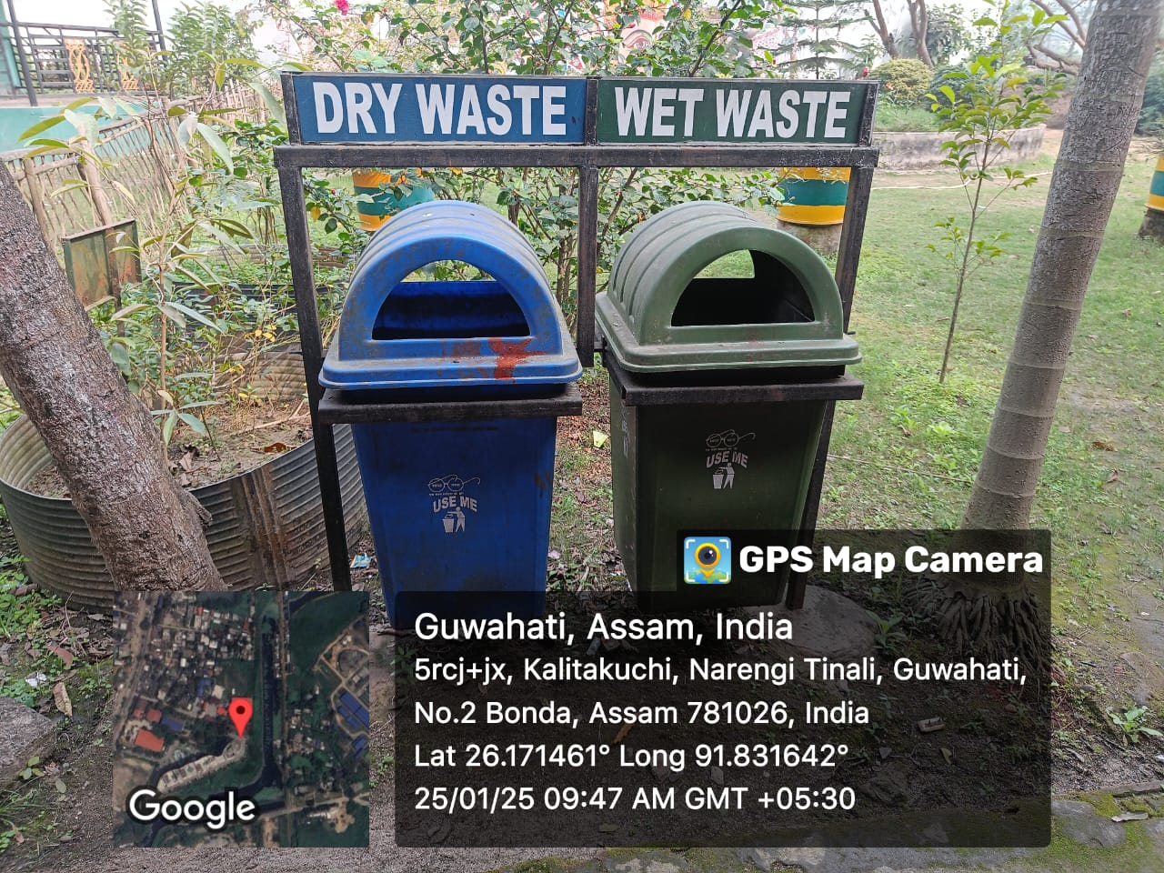
Separate Dustbins used for dry and wet waste

